# AACC-473[CRNT-41028]: Can't start sub process that provides a process interface

## MODEL and GO

1.Create New Process🡪 Name the Process

BusinessObject🡪CCCoreEntity

ManualStartPerformer🡪Administrator

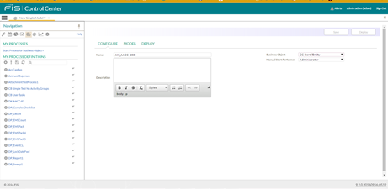

2. ModelTab🡪Implementation🡪IO execute EMS.

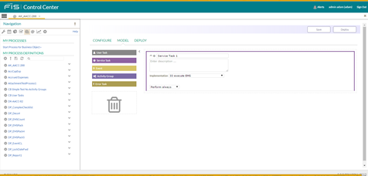

3.StartProcessForBusinessObject🡪EntityName=20140508

ProcessName🡪AK_AACC-288

BenchMark🡪MainBenchMark

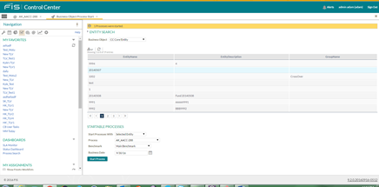

## MAIN

1.StatusDashBoard🡪AK_AACC-288

